

SOFTWARE DESIGN SPECIFICATION
Yu-Gi-Oh! Card Market & Deck Builder (YGO-MARKET)

– Hanoi, Nov 2026 –

Table of Contents
I. Record of Changes
II. Software Design Document
1. High Level Design
1.1 Software Architecture (3-Tier MERN)
1.2 Package Diagram
1.3 Database Design (users, cards, decks)
2. State Transition Diagrams
3. Detailed Design (Class Diagrams, Sequence Diagrams & APIs)
3.1 Authentication & User Profile Module
3.2 Card Catalog, Price & Translation Module
3.3 Deck Library Module
3.4 Admin Management Module

I. Record of Changes
Date | A* M, D | In charge | Change Description
23/10/2026 | A |  | Initial 3-Tier MERN architecture & MongoDB schema design.
05/11/2026 | A |  | Add desc_vi field & bilingual /api/cards/:id/translate endpoint specification.

*A - Added M - Modified D - Deleted

II. Software Design Document

1. High Level Design

1.1 Software Architecture
The system follows a 3-Tier Web Architecture implemented on the MERN stack: Presentation Layer (React 18 + Vite SPA), Application Layer (Node.js + Express.js REST API, Auth Middleware, Cron Scheduler & Static Image Server), and Data Layer (MongoDB yugioh_db via Mongoose ODM).
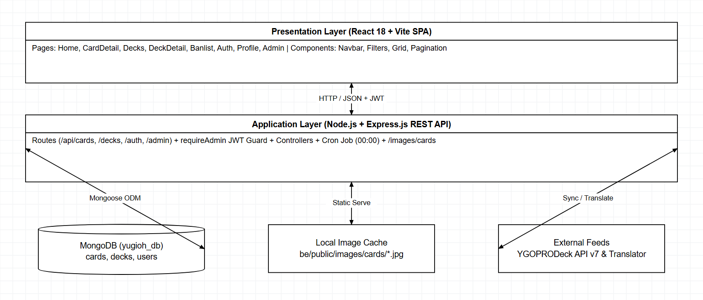
Figure 1.1: 3-Tier MERN Software Architecture

1.2 Package Diagram
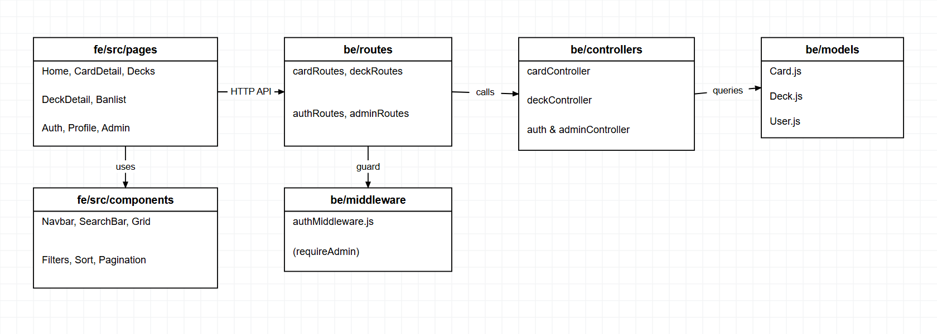
Figure 1.2: Package & Module Dependency Diagram
No | Package | Description
01 | fe/src/pages | HomePage.jsx, CardDetailPage.jsx, DecksPage.jsx, DeckDetailPage.jsx, BanlistPage.jsx, AuthPage.jsx, ProfilePage.jsx, AdminPage.jsx.
02 | fe/src/components | Navbar, SearchBar, CardFilter, CardSort, CardGrid, CardItem, LevelFilter, Pagination, ErrorBoundary.
03 | be/routes | cardRoutes.js, deckRoutes.js, authRoutes.js, adminRoutes.js.
04 | be/middleware | authMiddleware.js (JWT Bearer verification and requireAdmin guard).
05 | be/controllers | cardController.js, deckController.js, authController.js, adminController.js.
06 | be/models | Card.js, Deck.js, User.js (Mongoose schemas mapped to MongoDB yugioh_db).

1.3 Database Design
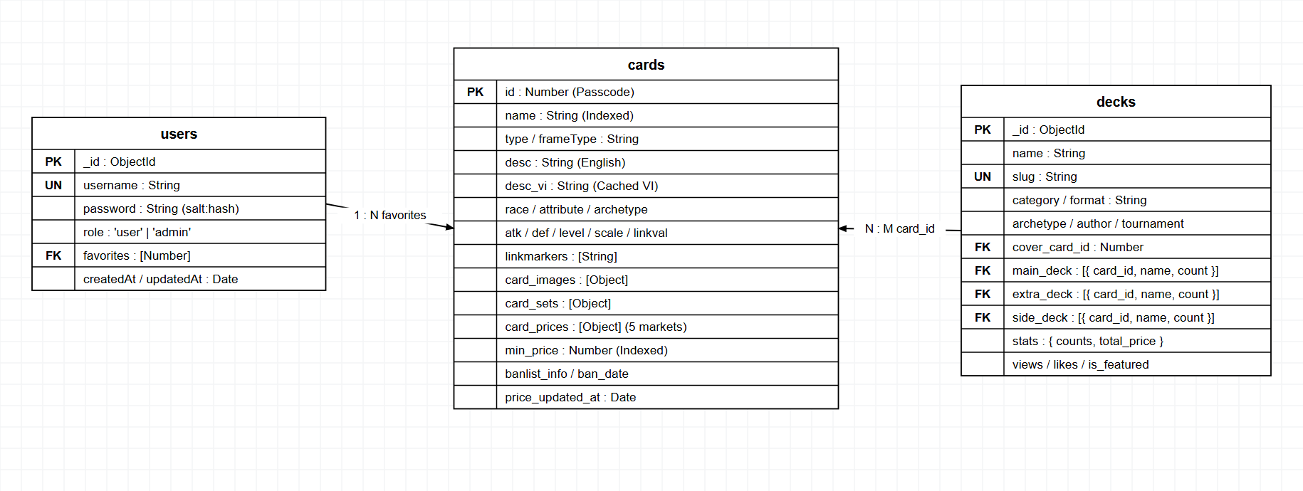
Figure 1.3: MongoDB Collections & Relationships (yugioh_db)

1.3.1 users
No | Field | PK | FK | UN | NN | Description
1 | _id | X |  |  | X | MongoDB ObjectId unique identifier.
2 | username |  |  | X | X | Unique trimmed login username (String).
3 | password |  |  |  | X | Hashed password stored as salt:hash via crypto.scrypt.
4 | role |  |  |  | X | Authorization role enum: 'user' (default) or 'admin'.
5 | favorites |  | X |  |  | Array of Card.id (Number) bookmarked by the user.
6 | createdAt / updatedAt |  |  |  | X | Mongoose automatic timestamps (Date).

1.3.2 cards
No | Field | PK | FK | UN | NN | Description
1 | id | X |  | X | X | Official Konami Passcode ID (Number, indexed).
2 | name |  |  |  | X | Official English card name (String, indexed).
3 | type / frameType |  |  |  | X | Card type & frameType (String).
4 | desc / desc_vi |  |  |  | X | English effect text & cached Vietnamese translation (desc_vi).
5 | race / attribute / archetype |  |  |  |  | Sub-type, Attribute, and Archetype (String).
6 | atk / def / level / scale / linkval |  |  |  |  | Combat & summoning stats (nullable by card type).
7 | linkmarkers |  |  |  |  | Array of String directional arrows for Link Monsters.
8 | card_images / card_sets / card_prices |  |  |  |  | Embedded arrays of images, print sets, and 5-market retail prices.
9 | min_price |  |  |  |  | Computed lowest numeric price across markets (indexed).
10 | banlist_info / ban_date / price_updated_at |  |  |  |  | TCG/OCG/GOAT ban status, effective date & sync timestamp.

1.3.3 decks
No | Field | PK | FK | UN | NN | Description
1 | _id | X |  |  | X | MongoDB ObjectId unique identifier.
2 | name / slug |  |  | X | X | Deck title and unique URL-friendly slug.
3 | category / format |  |  |  | X | Category & Format (TCG, OCG, Master Duel, GOAT, Edison).
4 | archetype / author / tournament |  |  |  |  | Archetype tag, deck builder, and tournament metadata.
5 | cover_card_id |  | X |  |  | Reference to Card.id used as cover artwork.
6 | main_deck / extra_deck / side_deck |  | X |  |  | Arrays of { card_id (Number), name (String), count (1-3) }.
7 | stats / views / likes / is_featured |  |  |  |  | Aggregated card counts, total_price, and engagement metrics.

2. State Transition Diagrams

2.1 Translation Cache & Price Lifecycle States
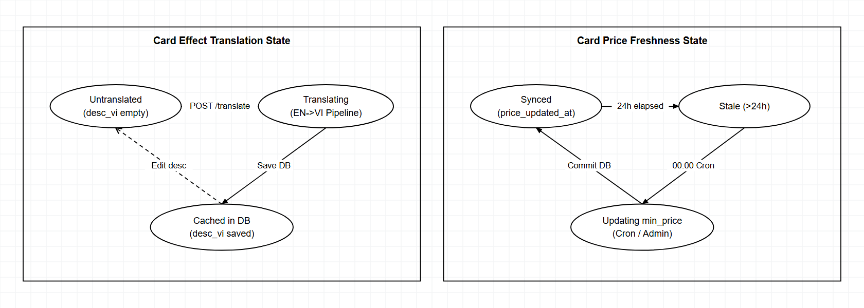
Figure 2.1: State Transition Diagrams - Translation Cache & Price Freshness

3. Detailed Design

3.1 Authentication & User Profile Module (/api/auth)

3.1.1 Class Diagram
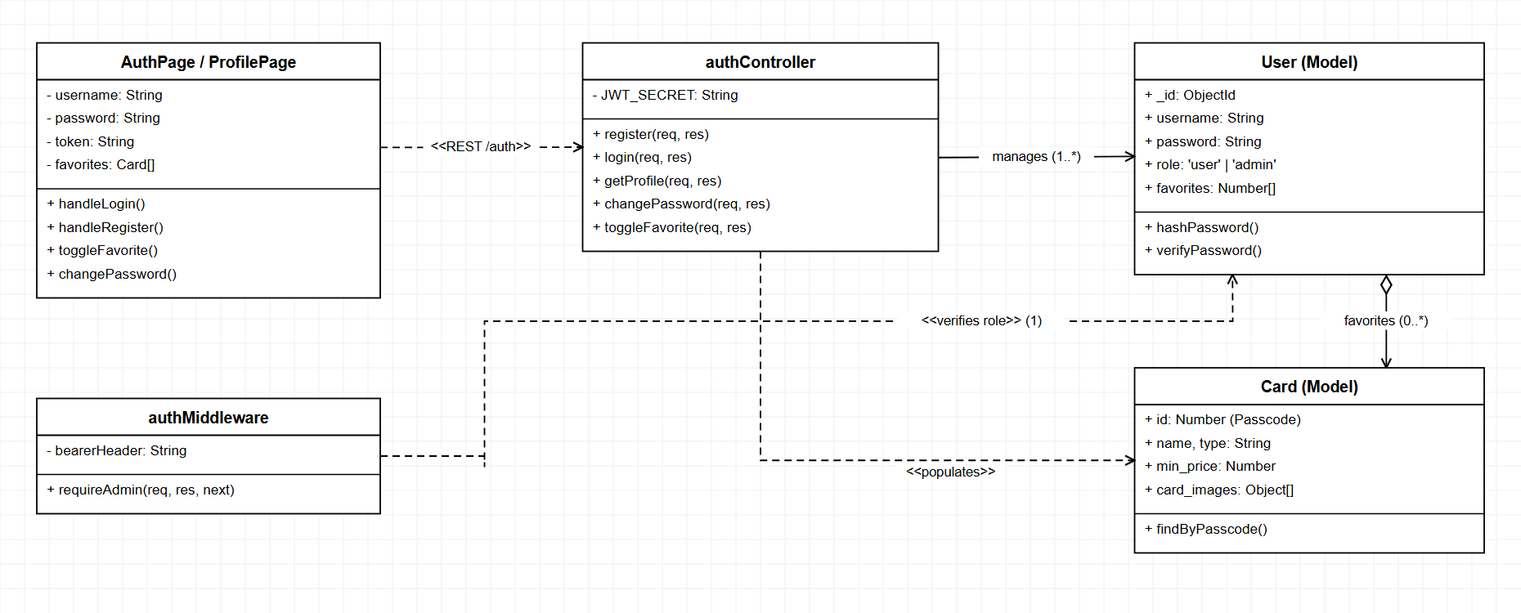
Figure 3.1.1: Class Diagram - Authentication & User Profile

3.1.2 Sequence Diagram - User Registration & Login
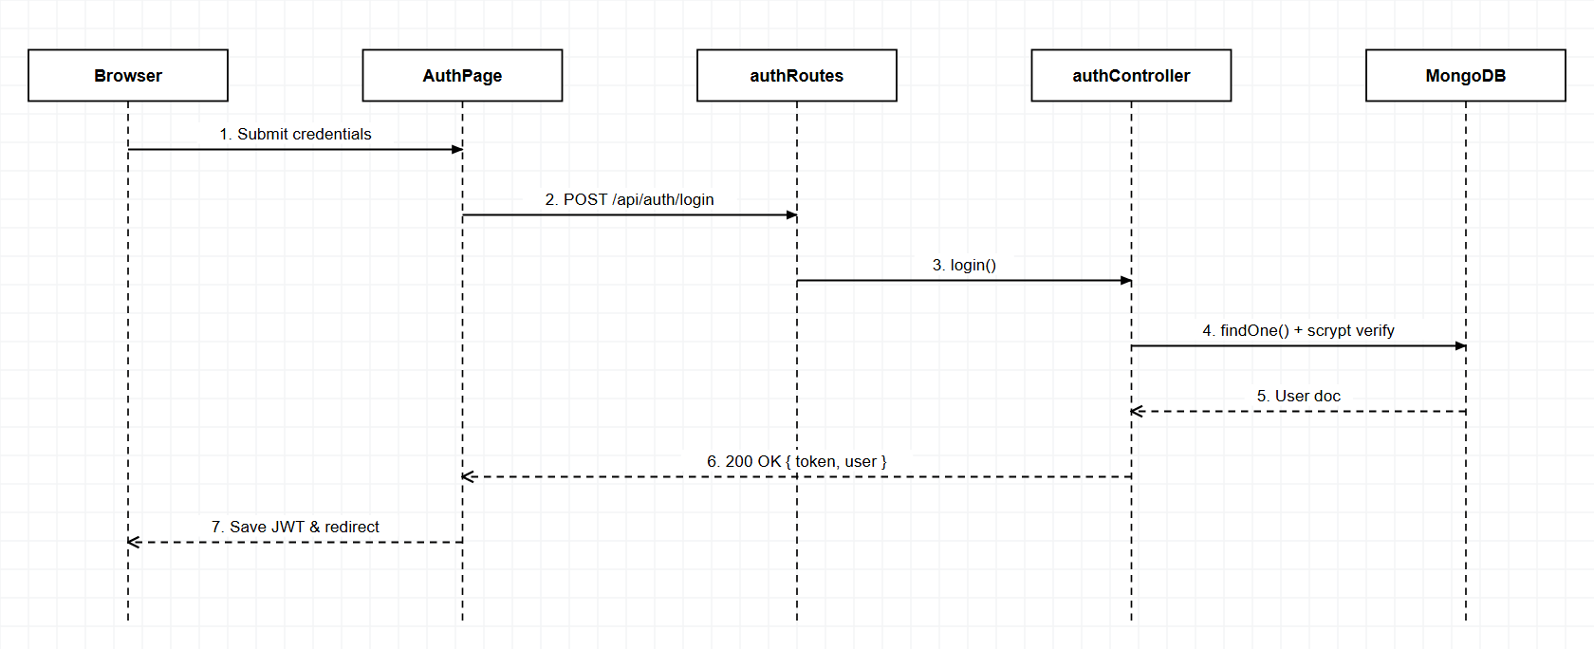
Figure 3.1.2: Sequence Diagram - User Registration & Login

3.1.3 Sequence Diagram - Toggle Favorite Card & Profile
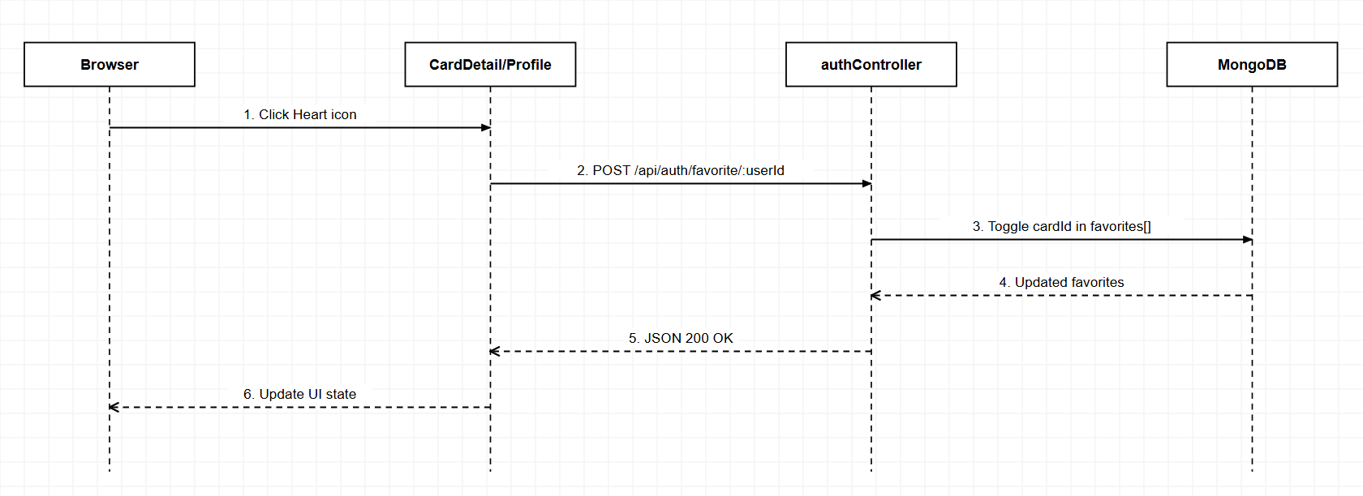
Figure 3.1.3: Sequence Diagram - Toggle Favorite Card & Profile

3.1.4 REST API Endpoints
Method | Endpoint | Auth | Handler | Logic & Response
POST | /api/auth/register | Public | authController.register | Validate unique username, hash password (scrypt), save User, return 201 + JWT.
POST | /api/auth/login | Public | authController.login | Verify scrypt hash, return 200 + JWT (7d) + user profile.
GET | /api/auth/profile/:userId | User | authController.getProfile | Fetch User excluding password and populate favorite cards.
PUT | /api/auth/change-password/:userId | User | authController.changePassword | Verify oldPassword, re-hash newPassword, persist.
POST | /api/auth/favorite/:userId | User | authController.toggleFavorite | Toggle cardId inside user.favorites array and return updated list.

3.2 Card Catalog, Price & Translation Module (/api/cards)

3.2.1 Class Diagram
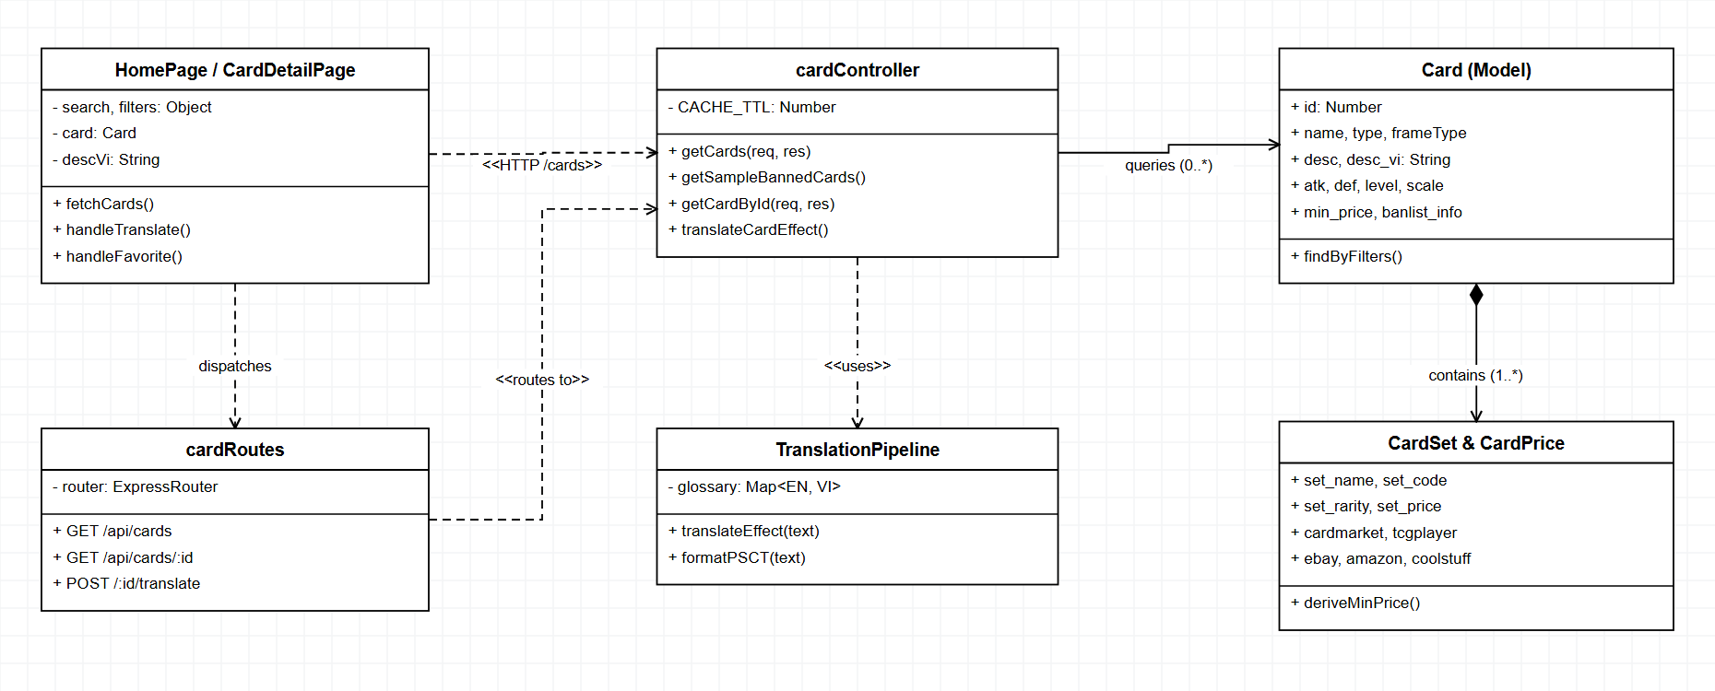
Figure 3.2.1: Class Diagram - Card Catalog, Price & Translation

3.2.2 Sequence Diagram - Browse, Search & Filter Cards
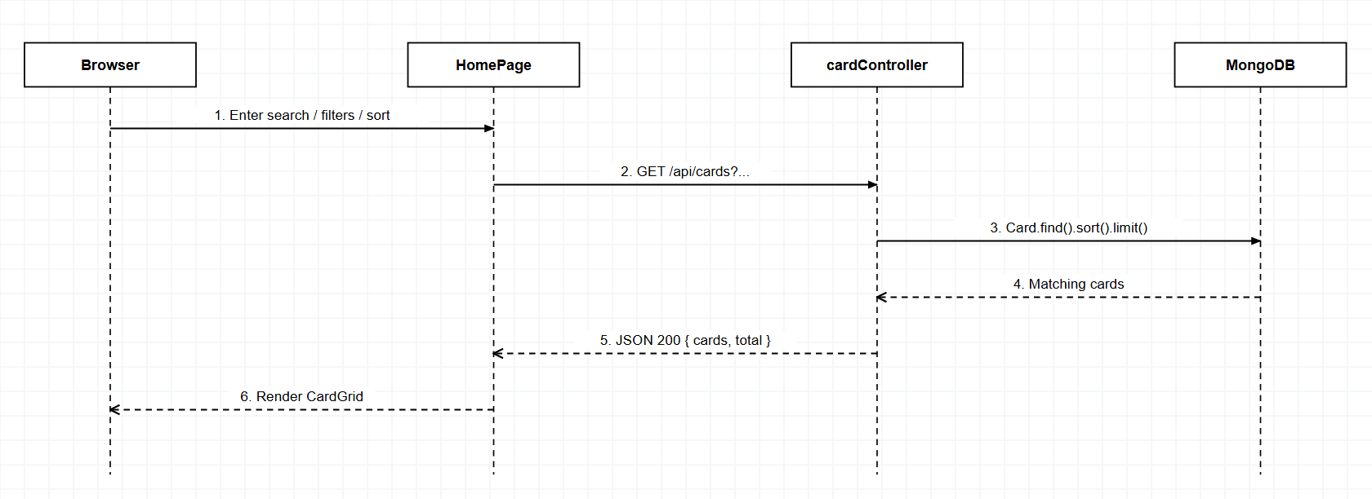
Figure 3.2.2: Sequence Diagram - Browse, Search & Filter Cards

3.2.3 Sequence Diagram - Card Detail & EN/VI Translation
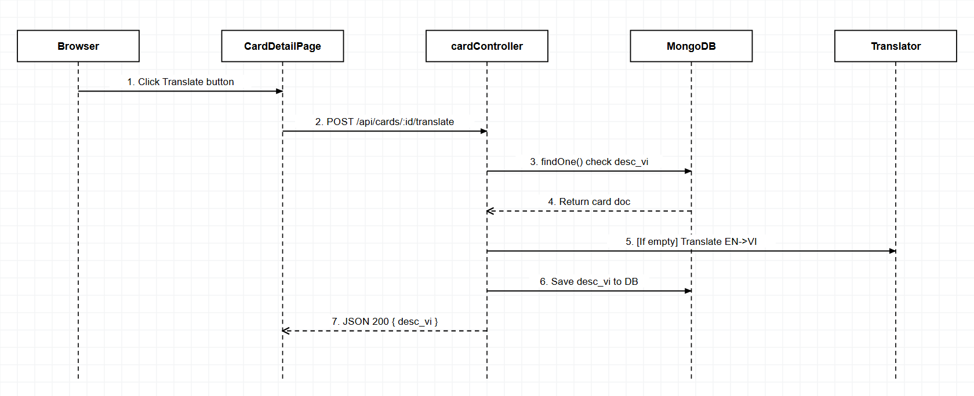
Figure 3.2.3: Sequence Diagram - Card Detail & EN/VI Translation

3.2.4 REST API Endpoints
Method | Endpoint | Auth | Handler | Logic & Response
GET | /api/cards | Public | cardController.getCards | Dynamic MongoDB filter (name regex, type, attr, race, level, archetype, banlist), sort & pagination.
GET | /api/cards/sample/banned | Public | cardController.getSampleBannedCards | Return cards with non-empty banlist_info.
GET/POST | /api/cards/:id/translate | Public | cardController.translateCardEffect | Return cached desc_vi if present; else translate EN->VI & save to DB.
GET | /api/cards/:id | Public | cardController.getCardById | Return full Card document with 5-market prices and card_sets.

3.3 Deck Library Module (/api/decks)

3.3.1 Class Diagram
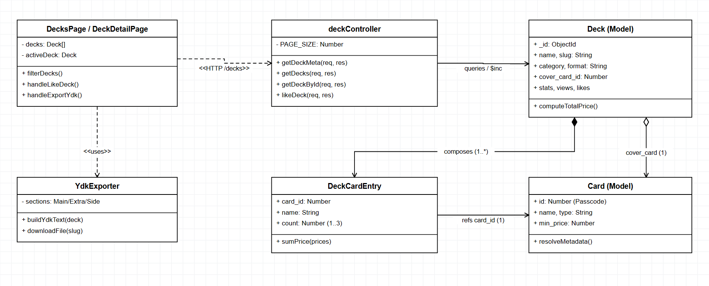
Figure 3.3.1: Class Diagram - Deck Library

3.3.2 Sequence Diagram - View Deck Detail, Like & Export .ydk
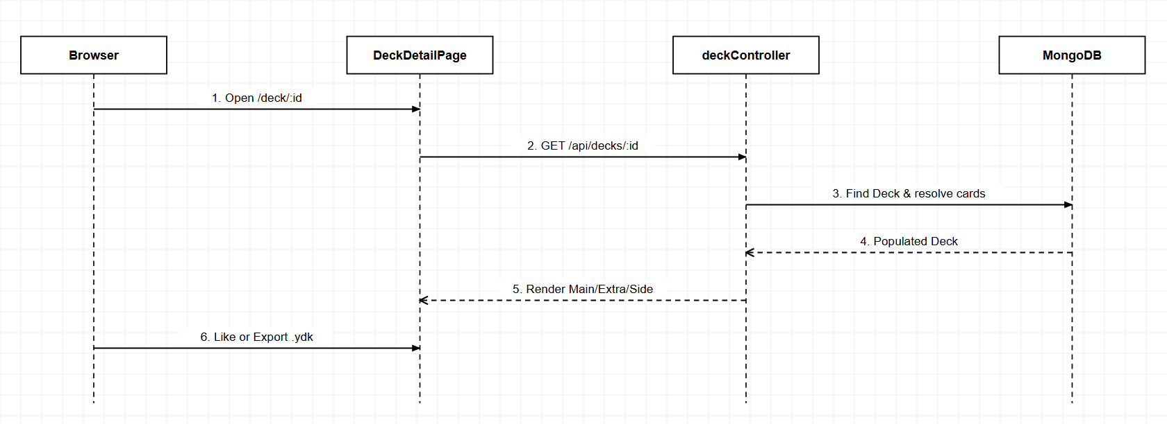
Figure 3.3.2: Sequence Diagram - View Deck Detail, Like & Export .ydk

3.3.3 REST API Endpoints
Method | Endpoint | Auth | Handler | Logic & Response
GET | /api/decks/meta | Public | deckController.getDeckMeta | Return distinct categories, formats, and archetypes.
GET | /api/decks | Public | deckController.getDecks | Filter by search, category, format, price range & paginate.
GET | /api/decks/:id | Public | deckController.getDeckById | Fetch Deck by _id or slug and resolve component card metadata.
POST | /api/decks/:id/like | Public | deckController.likeDeck | Atomic $inc likes counter (+1).

3.4 Admin Management Module (/api/admin)

3.4.1 Class Diagram
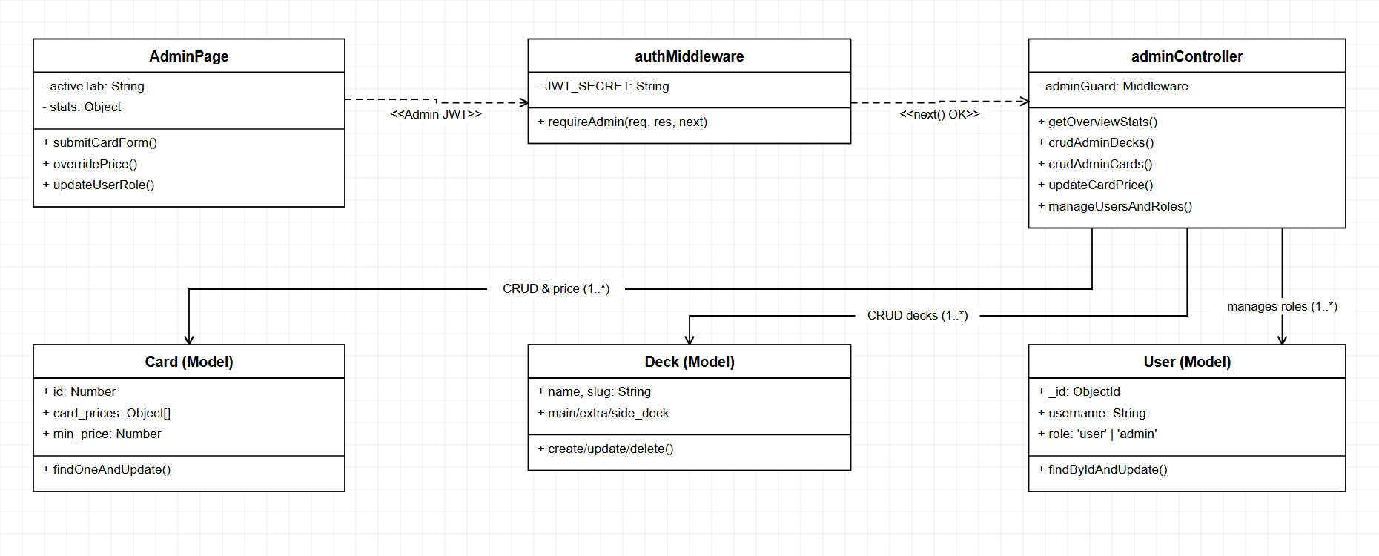
Figure 3.4.1: Class Diagram - Admin Management

3.4.2 Sequence Diagram - Admin Cards CRUD & Price Override
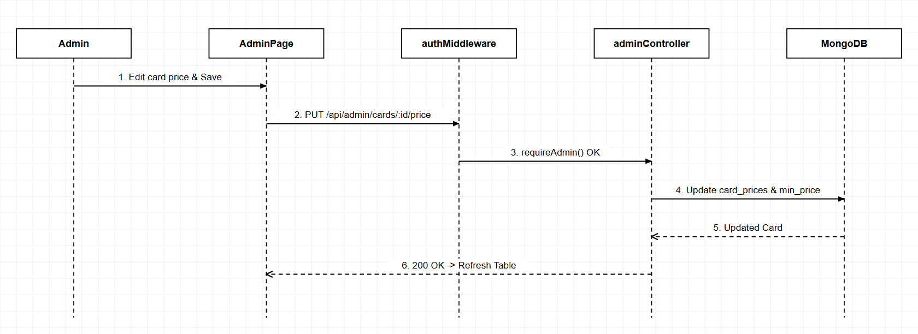
Figure 3.4.2: Sequence Diagram - Admin Cards CRUD & Price Override

3.4.3 Sequence Diagram - Admin Decks CRUD & User Role Management
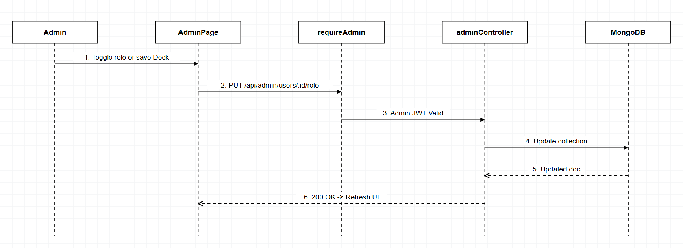
Figure 3.4.3: Sequence Diagram - Admin Decks CRUD & User Role Mgmt

3.4.4 REST API Endpoints (Protected by requireAdmin)
Method | Endpoint | Handler | Logic & Response
GET | /api/admin/stats | adminController.getOverviewStats | Count documents across cards, decks, and users collections.
GET/POST/PUT/DELETE | /api/admin/decks(/:id) | adminController.*AdminDeck | Full CRUD operations on decks collection.
GET/POST/PUT/DELETE | /api/admin/cards(/:id) | adminController.*AdminCard | Full CRUD operations on cards collection.
PUT | /api/admin/cards/:id/price | adminController.updateCardPrice | Override 5-market prices and recompute min_price.
GET/PUT/DELETE | /api/admin/users(/:id)(/role) | adminController.*User* | List users, toggle role ('user'/'admin'), or delete user.

